**Executive Tours South Island**

**Private Tours**

4 nights 5 Day **Scenic** South Island tours

**Christchurch > Franz Josef > Wanaka > Twizel > Aoraki Mount Cook > Lake Tekapo > Christchurch**

**Tour map of visiting locations.**

Starting in Christchurch city at 09:00.

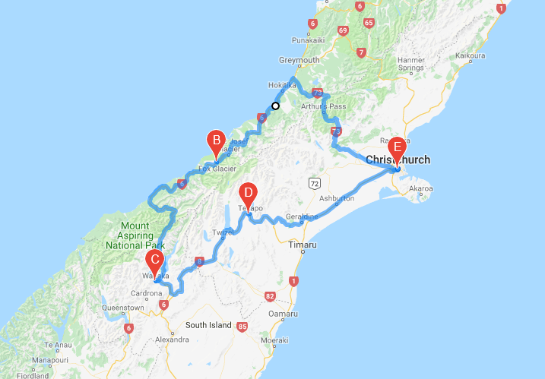

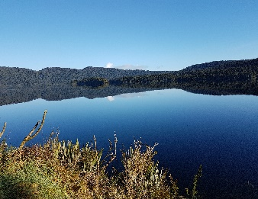

**DAY ONE:**

Heading to the Main divide mountain range, stopping for mountain views, Rock formations Castle rock, Arthur’s Pass see the mountain parrot the Kia, waterfalls, Hokitika township on our way to Franz Josef for our first night.

Incredable lake views before we reach Franz Josef, with plentry of photo stopping opportunitites.

Travelling from one side of the island to the other.

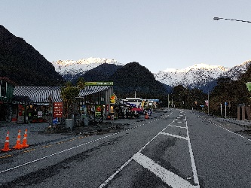

**DAY ONE AND TWO**:

Franz Josef township. 2 nights stay.

Opportunity to take the Franz Josef Glacier walk/ Helicopter scenic ride or the Heli Hiking and at night sit back in the hot pools. Local craft and souvenir stores welcome you. Clean fresh air . The next day journey over the Haast pass.

Leaving Franz Josef around 9am.

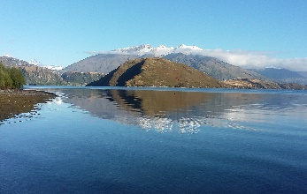

**DAY THREE:** Lake Wanaka one night. This amazing journey down the West Coast of New Zealand is a spectacular journey. Things to do at Lake Wanaka: Sky driving, visit puzzle world, go for a boat ride or just walk around the lake.

Gentle walk to the famous one tree at lake Wanaka.

Leaving Lake Wanaka, the next morning about 9am over the Lindis pass.

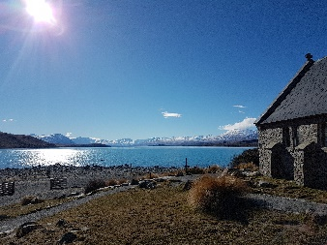

**DAY FIVE**: On our way back to Christchurch city we will stopping at the Famous Fairlie Bakery, travel over the rolling hills to Geraldine township and onto the Canterbury planes to Christchurch city for a short tour of this amazing city.

Ether you can stay the night in Christchurch or take you directly to the Christchurch airport.

**DAY FOUR**: Lake Tekapo. Stay one night. Viewing the clear turquoise Lakes first Pukaki then Tekapo. We stop at the top of lake Pukaki to buy some freshly farmed Salon. When at Lake Tekapo we can arrange the Dark skies star gazing tour if required. Try out the view from the hot pools of the mountains while sitting back and relaxing during the day or night.

Leaving Tekapo at 11am for Christchurch city.

**What we provide:**

* Personal chauffeur private tour
* Local business local driver/guide
* Personal service to meet your requirements.
* Comfortable European vehicles.
* Vehicle/fuel/ vehicle insurance/driver-guide.
* NZ government tax of 15%

**What you must provide:**

* Accommodation: As everyone has their own accommodations and meals requirements, we provide the location we are staying in, and you choose your own accommodation and restaurant’s, or we can assist you with this. Try Booking.com or Trivago for suggestions but please check with us to confirm you are staying in a close proximity to our location:
* Meals:
* Personal travel insurance:
* All other personal belonging:
* Activities are not included in our pricing, but we can arrange these for you.

Our Chauffeured tours are private with groups from one up to 11 guests and designed for the scenery and or adventure in you. Ideal for family groups only as we do not operate as a bus company mixing up our passengers.

As a bespoke tour chauffeur service, we can adapt your requirements. Our pricing includes New Zealand Government tax of 15%.

Our tours are charged as **per vehicle** size as listed below and luggage capacity indicated. Not per passenger.

**Mercedes Benz S350 Class luxury sedan**. 2 passengers/2 suitcases 1 carry on.

$ per day / 5 days / 2 passengers. Price: $ NZD

**Mercedes Benz Ambiente luxury minivan**. 6 passengers / up to 12 suitcases with trailer.

$ per day / 5 days / 6 passengers. Price: $ NZD

**Mercedes Sprinter or alike:** 11 seats / 12 suitcases with trailer if required.

$ per day / 5 days / 11 passengers. Price: $ NZD

**Please contact us we can discuss your preferences:**

* Style of vehicle
* Suggested activities
* Other places to visit while on this scenery tour.